LAB EXPERIMENTS
TOPIC 5
NAME: CHANDRA KALA TORAM
REG NO: 192372224
COURSE CODE: CSA0608
COURSE NAME: DESIGN AND ANALYSIS OF ALGORITHM

Question 1: Search an Element in a Sorted Array
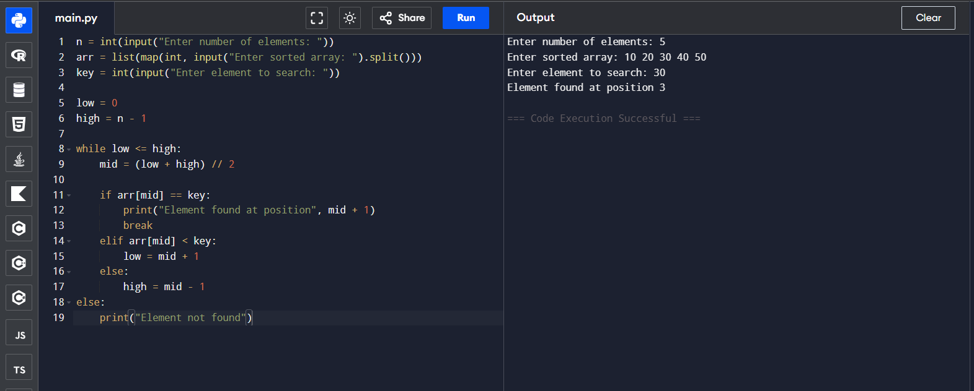
Question 2: Find the Index of a Given Number
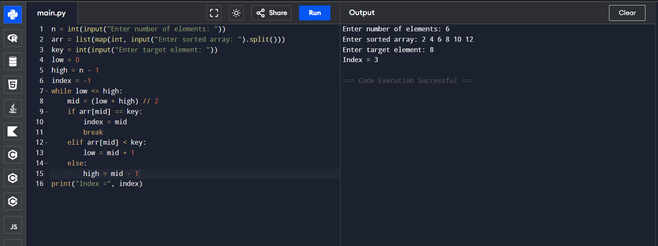
Question 3: Count the Number of Iterations in Binary Search
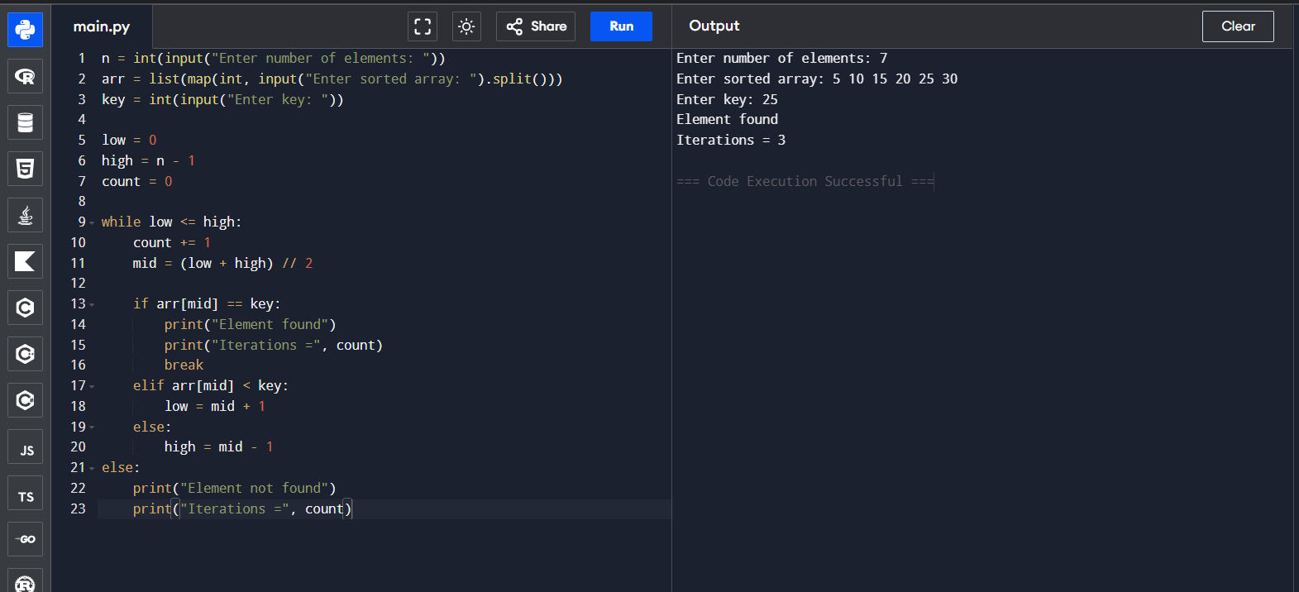

Question 4: Find the First Occurrence of an Element
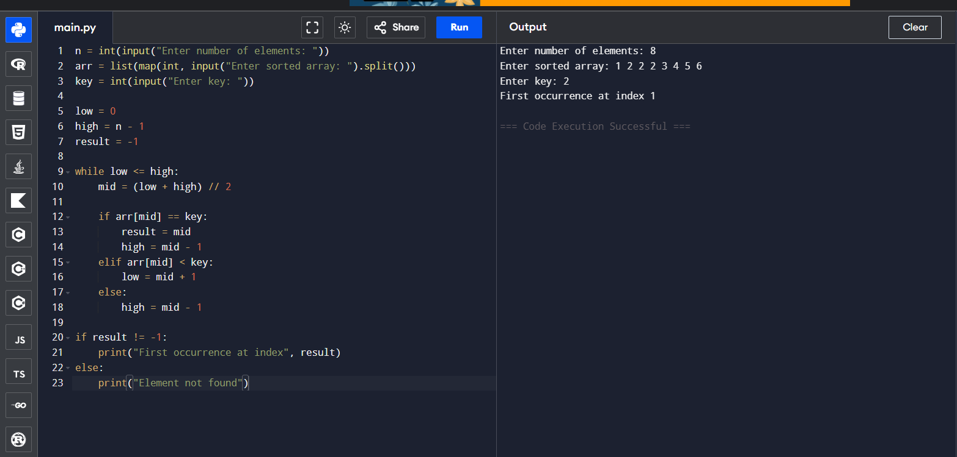
Question 5: Find the Last Occurrence of an Element
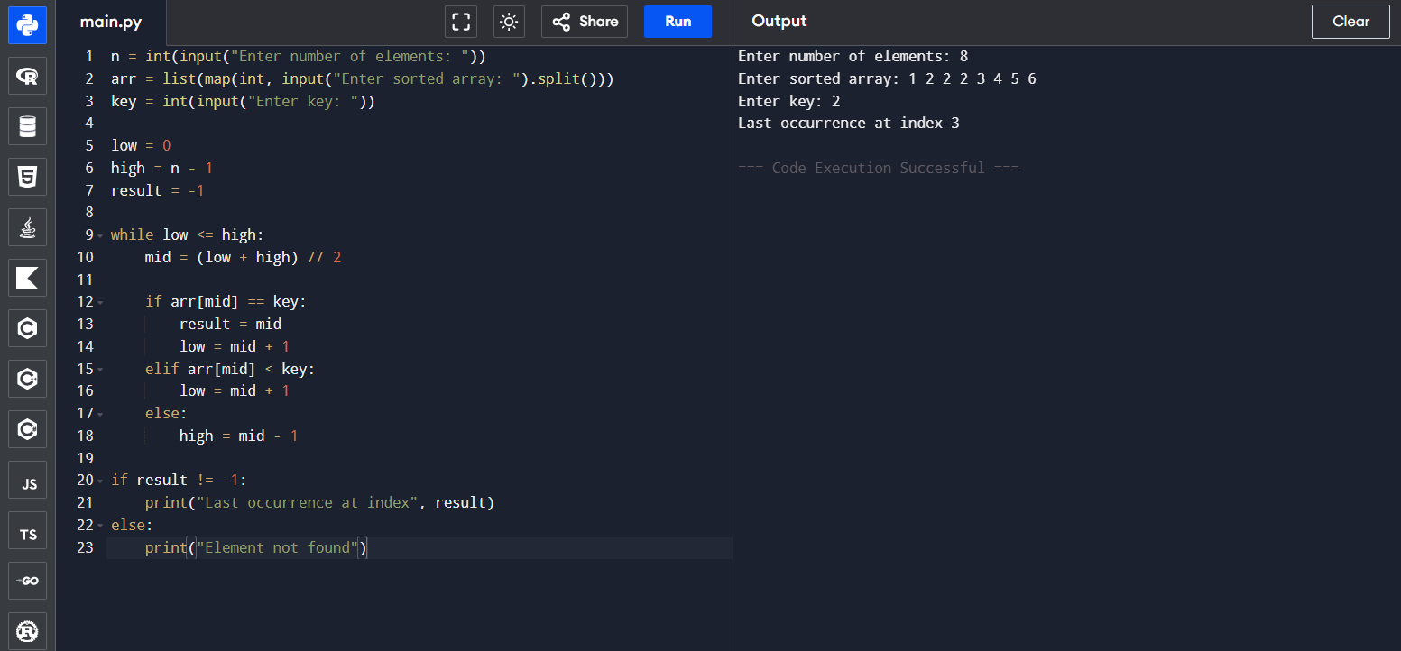
Question 6: Highest and Lowest Temperature Recorded
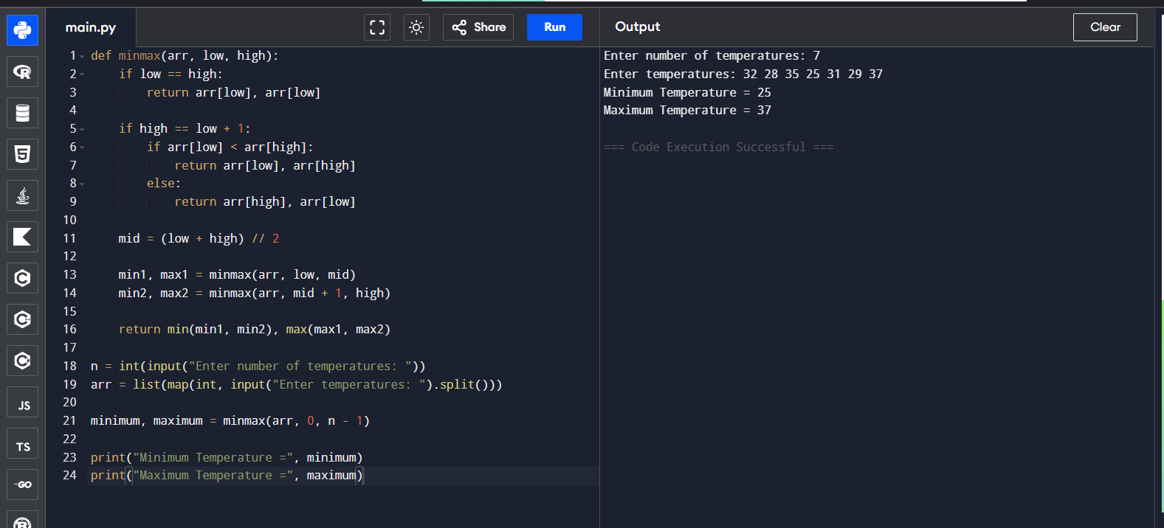
Question 7: Best and Worst Student Marks
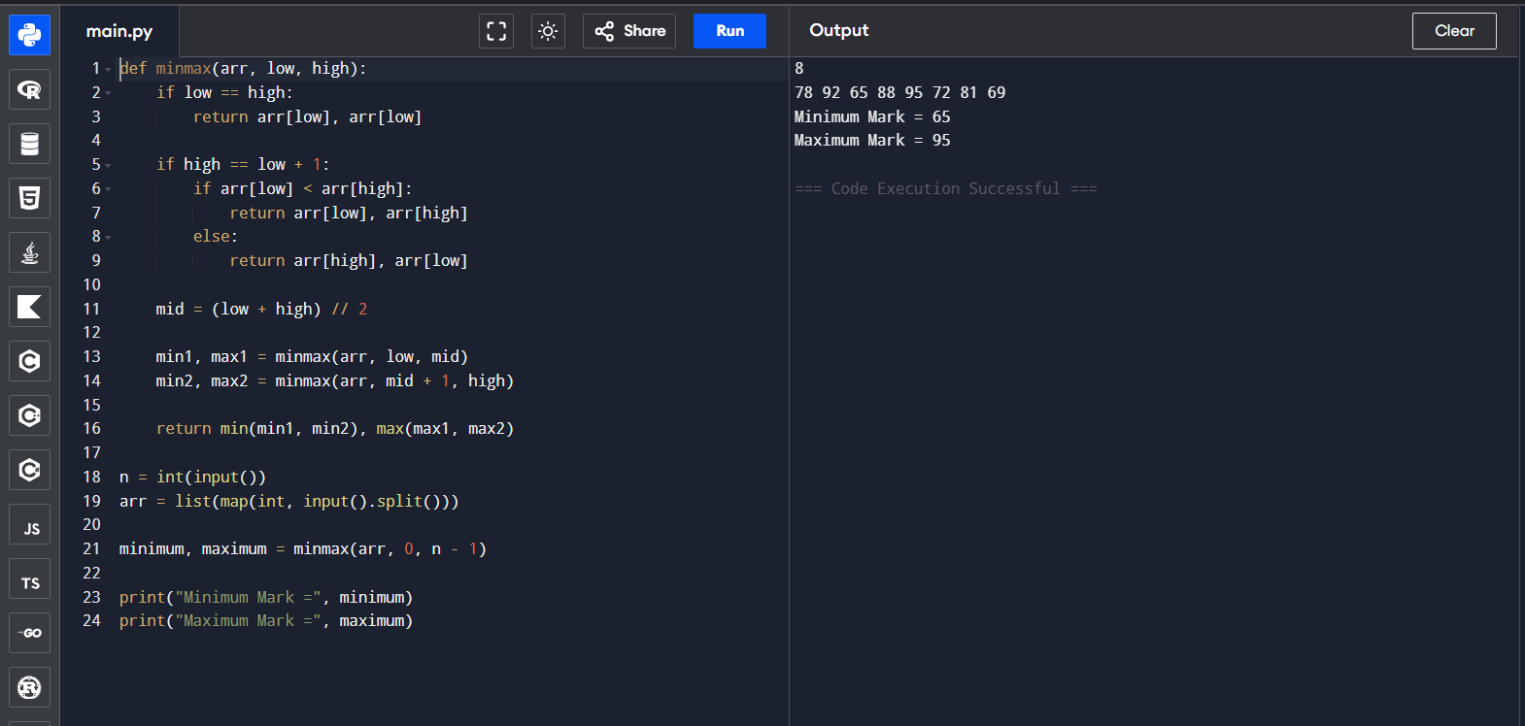
Question 8: Stock Price Analysis
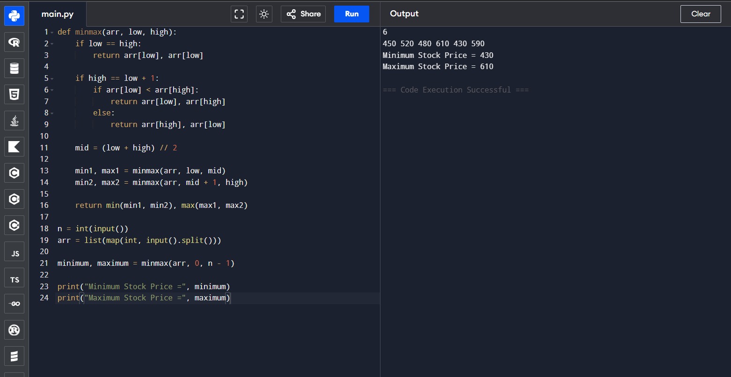
Question 9: Fastest and Slowest Race Times
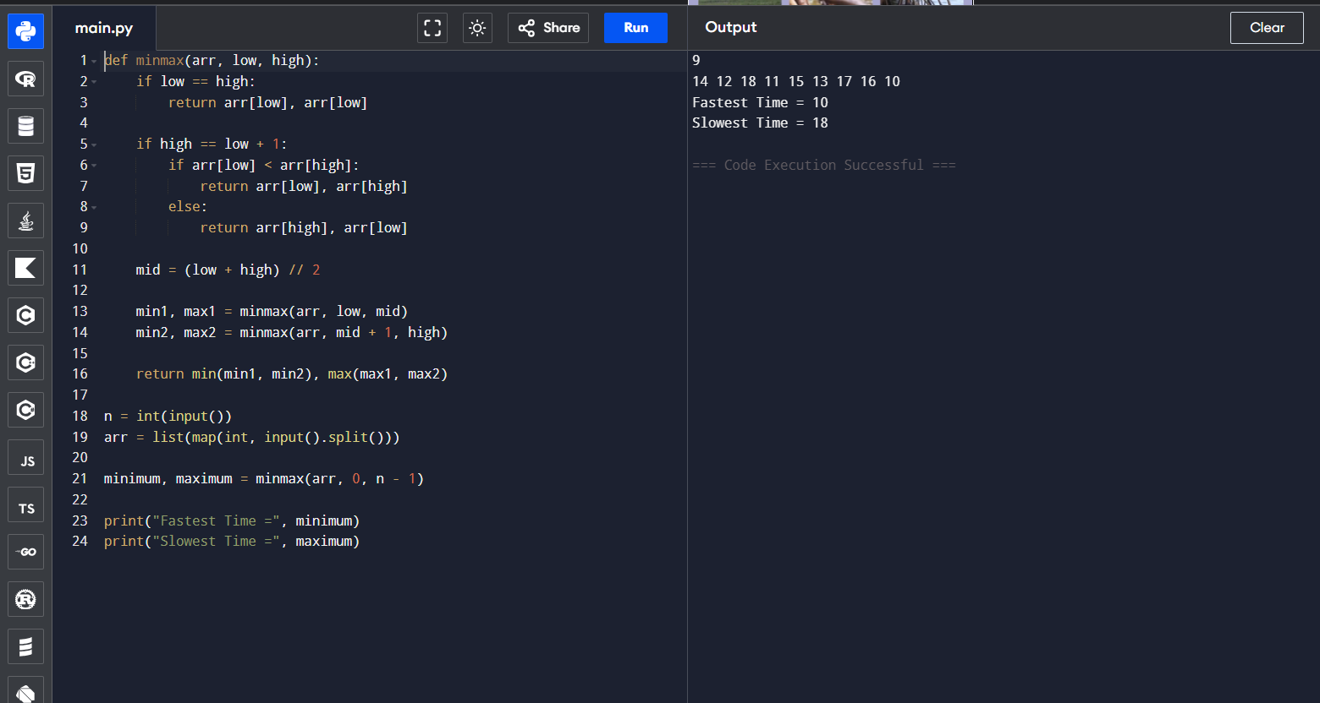
Question 10: Largest and Smallest Building Heights
